**Name :** V Venkata Sri Prasad

**Batch:** Data Engineering

**Date:** 23/04/2023 – Day 5

**Topics:**

Data Cleaning & Transformation

Using Rank Functions

What is Stored Procedures

**Data Cleaning & Transformation:**

**Missing values**

**NULL values:**

**--IS NULL**

**SELECT \***

**FROM ExampleTable**

**WHERE Name IS NULL OR Age IS NULL OR City IS NULL;**

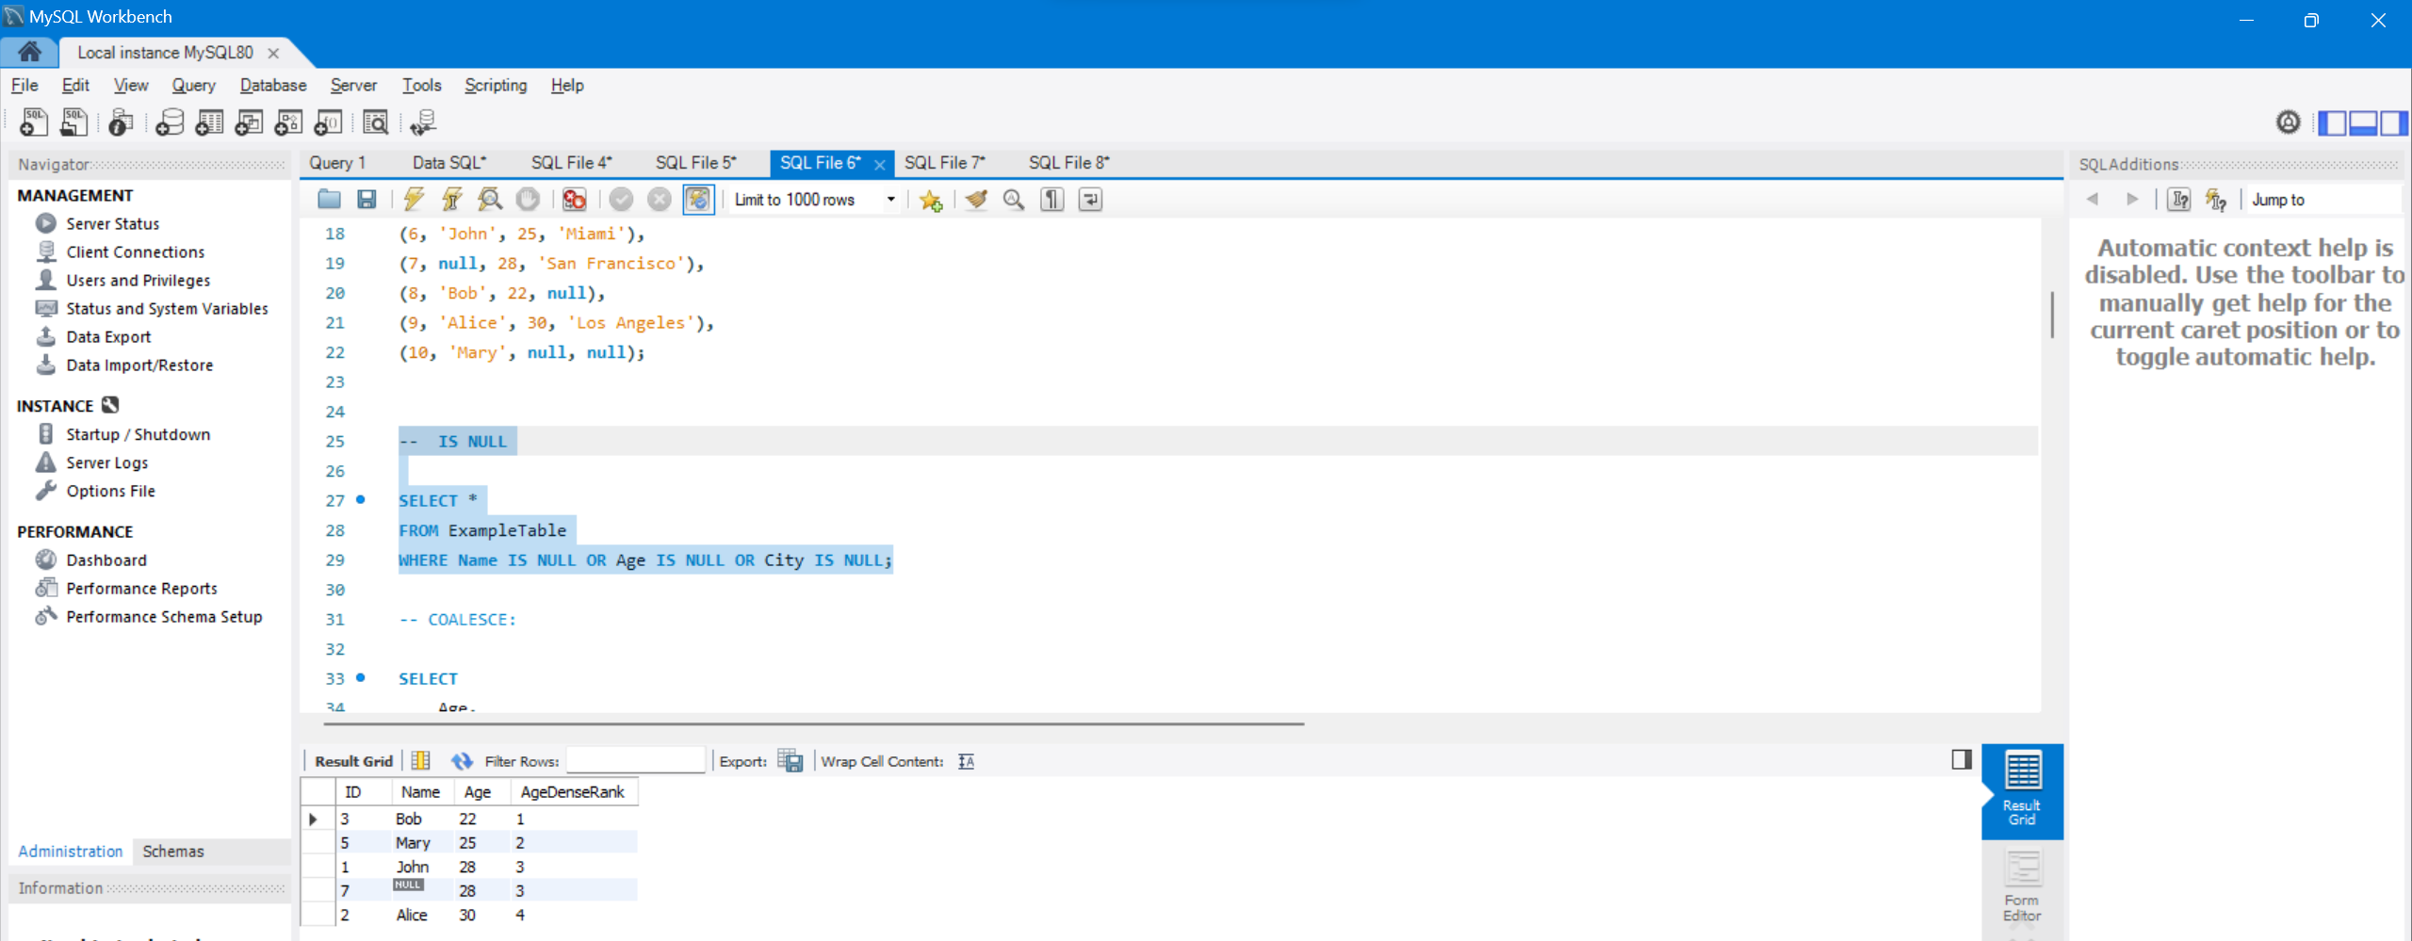

**-- COALESCE:**

**SELECT**

**Age,**

**COALESCE(Age, 30) AS NewAge**

**FROM ExampleTable;**

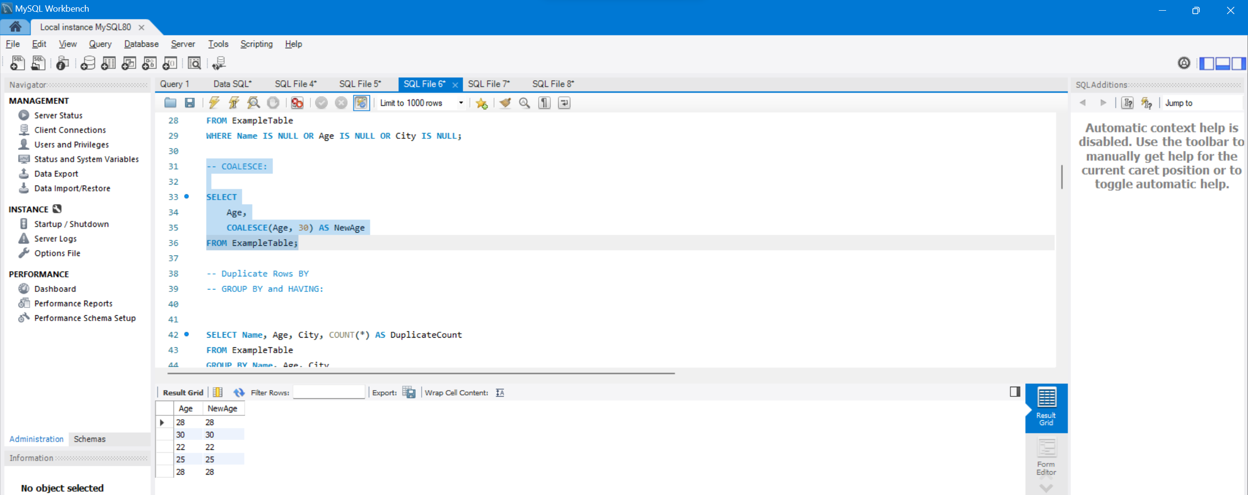

**-- Duplicate Rows BY**

**-- GROUP BY and HAVING:**

**SELECT Name, Age, City, COUNT(*) AS DuplicateCount**

**FROM ExampleTable**

**GROUP BY Name, Age, City**

**HAVING COUNT(*) > 1;**

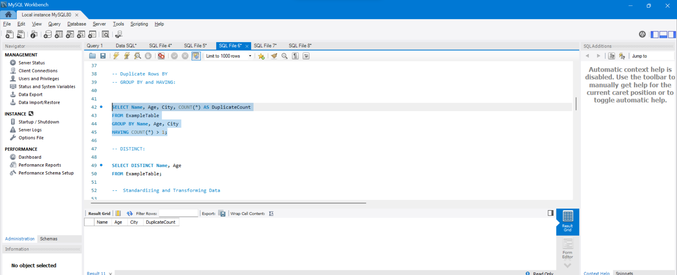

**-- DISTINCT:**

**SELECT DISTINCT Name, Age**

**FROM ExampleTable;**

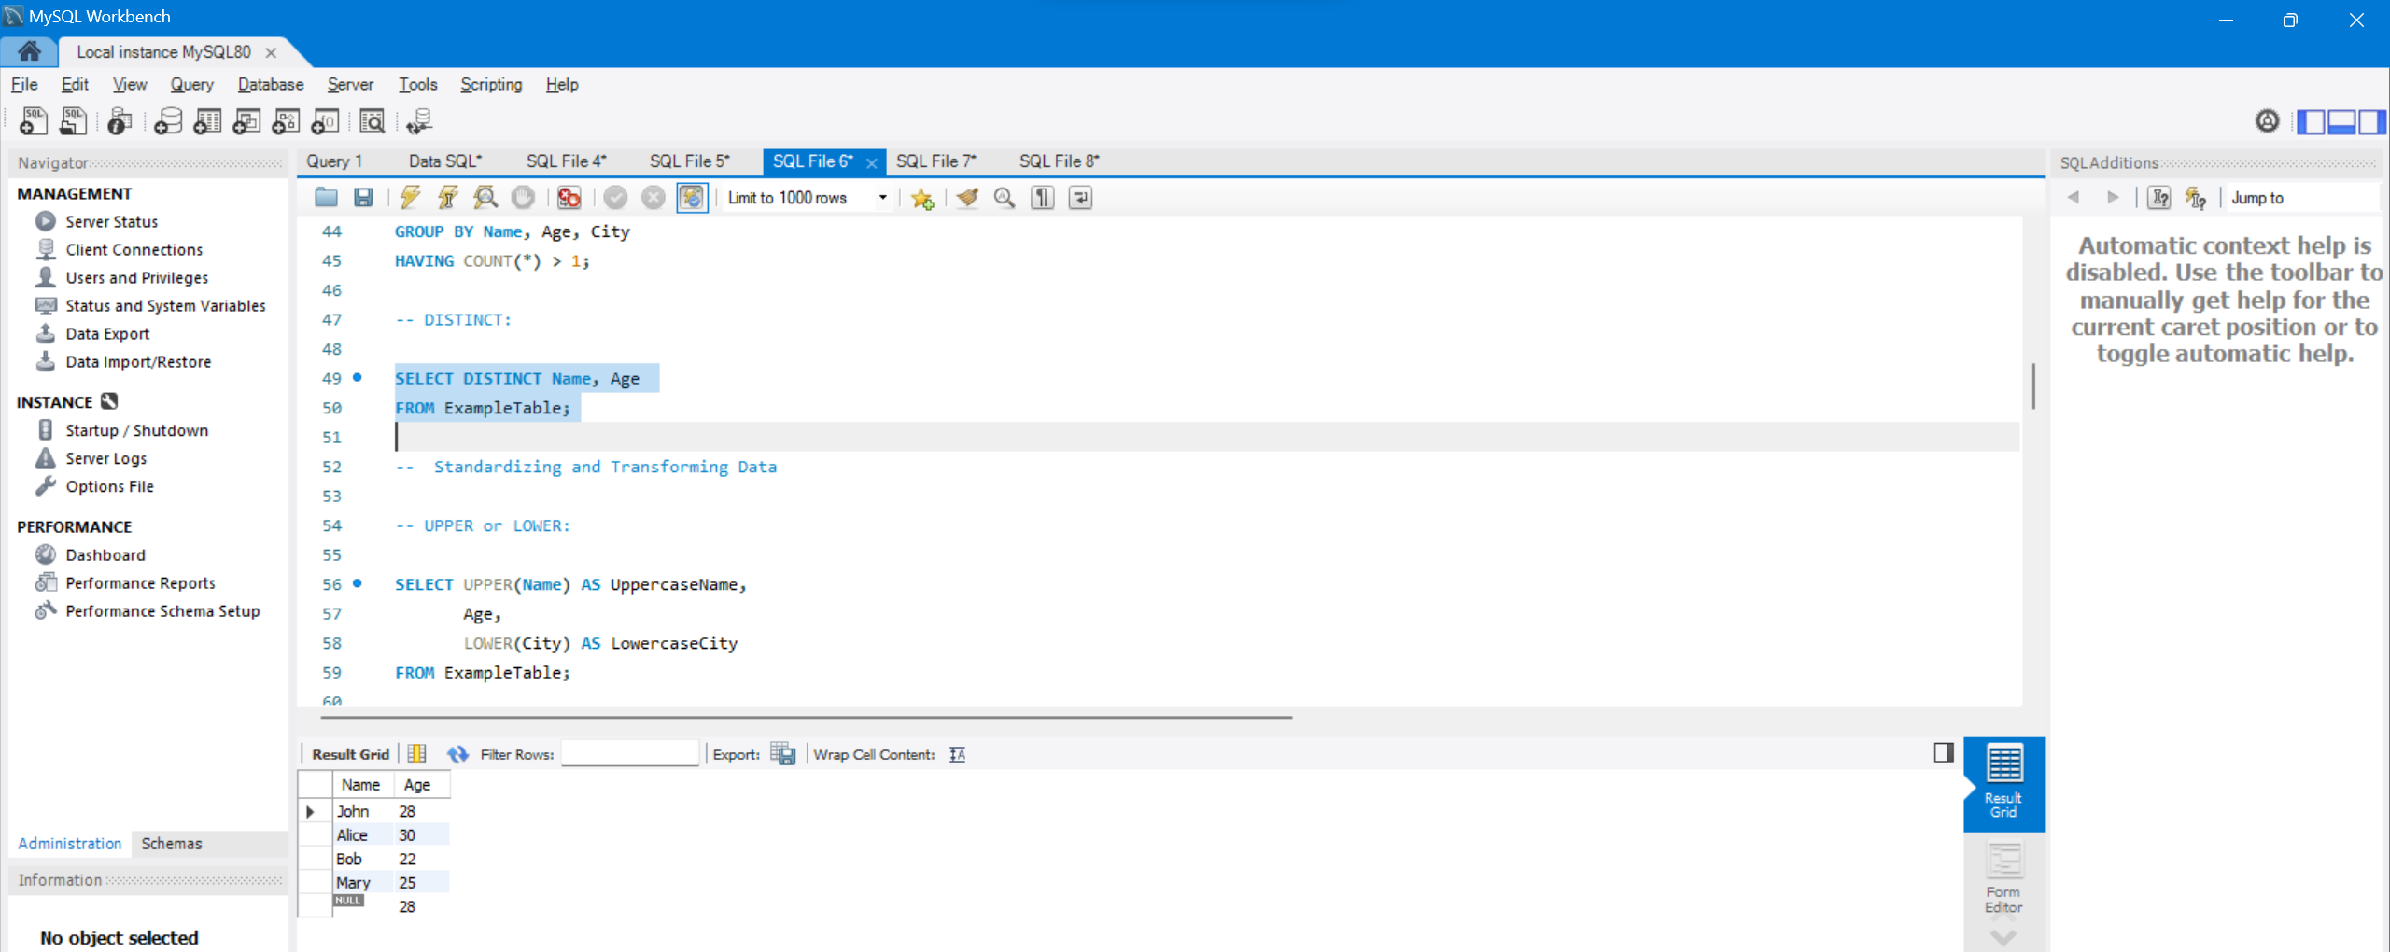

**Standardizing and Transforming Data:**

**-- UPPER or LOWER:**

**SELECT UPPER(Name) AS UppercaseName,**

**Age,**

**LOWER(City) AS LowercaseCity**

**FROM ExampleTable;**

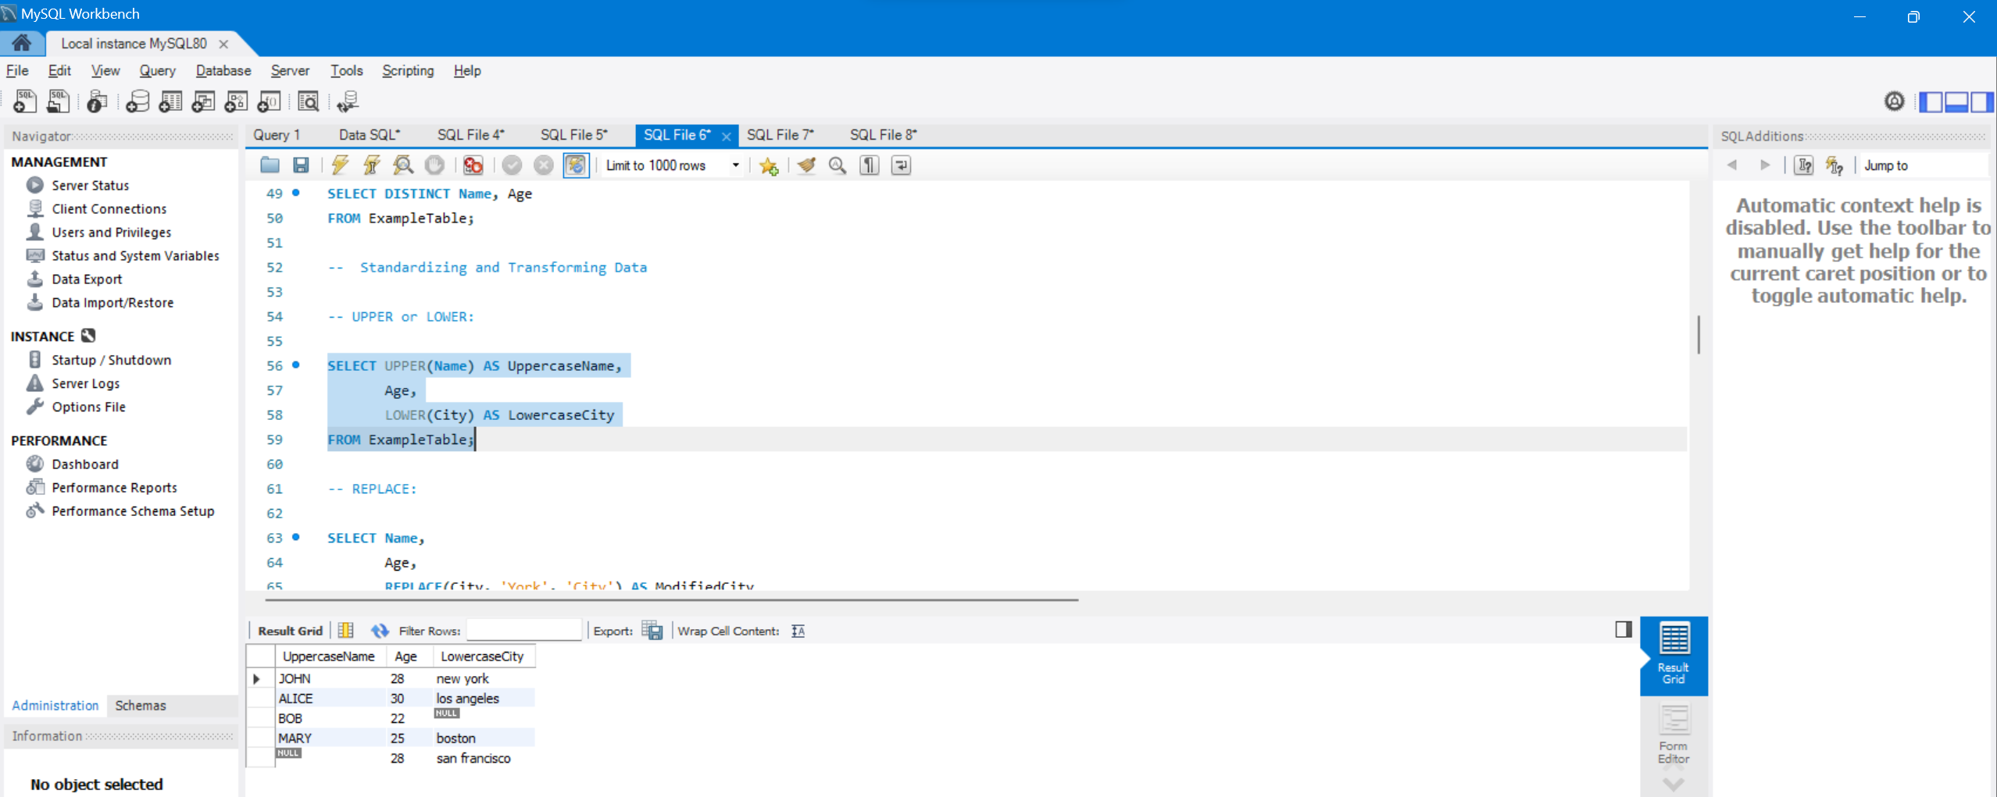

**-- REPLACE:**

**SELECT Name,**

**Age,**

**REPLACE(City, 'York', 'City') AS ModifiedCity**

**FROM ExampleTable;**

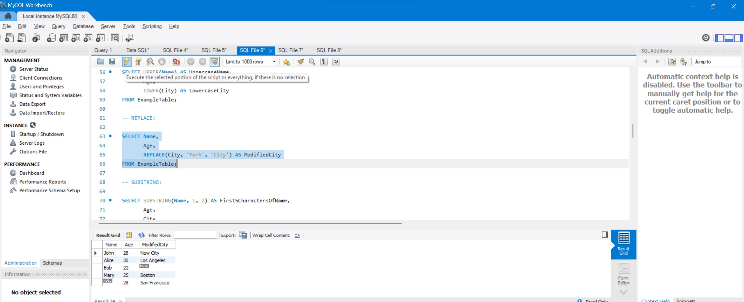

**-- SUBSTRING:**

**SELECT SUBSTRING(Name, 1, 2) AS First5CharactersOfName,**

**Age,**

**City**

**FROM ExampleTable;**

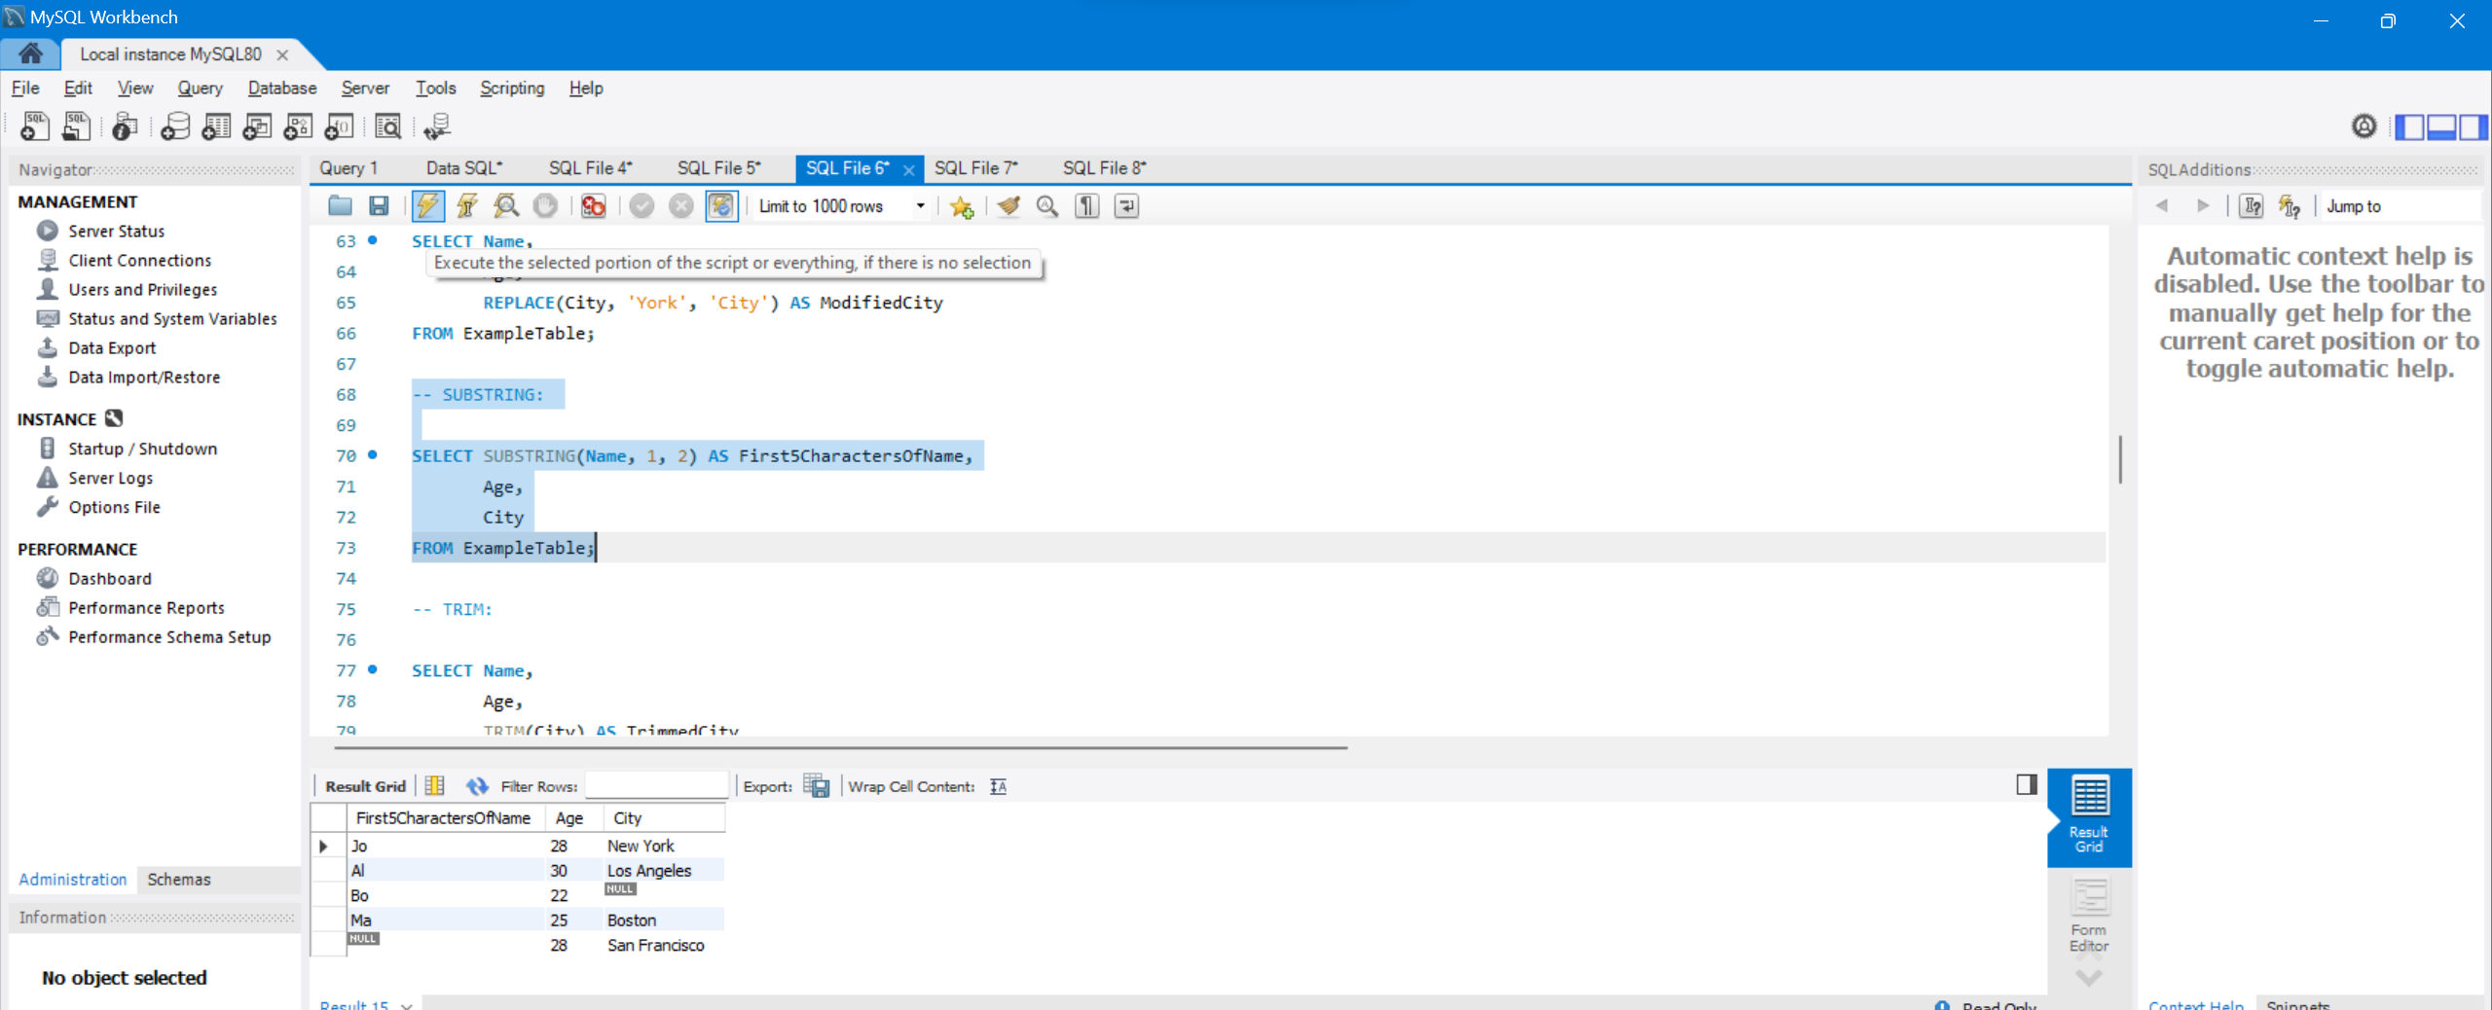

**-- TRIM:**

**SELECT Name,**

**Age,**

**TRIM(City) AS TrimmedCity**

**FROM ExampleTable;**

**SELECT TRIM("#SQL" FROM "#SQL Hexware!") AS TrimmedString;**

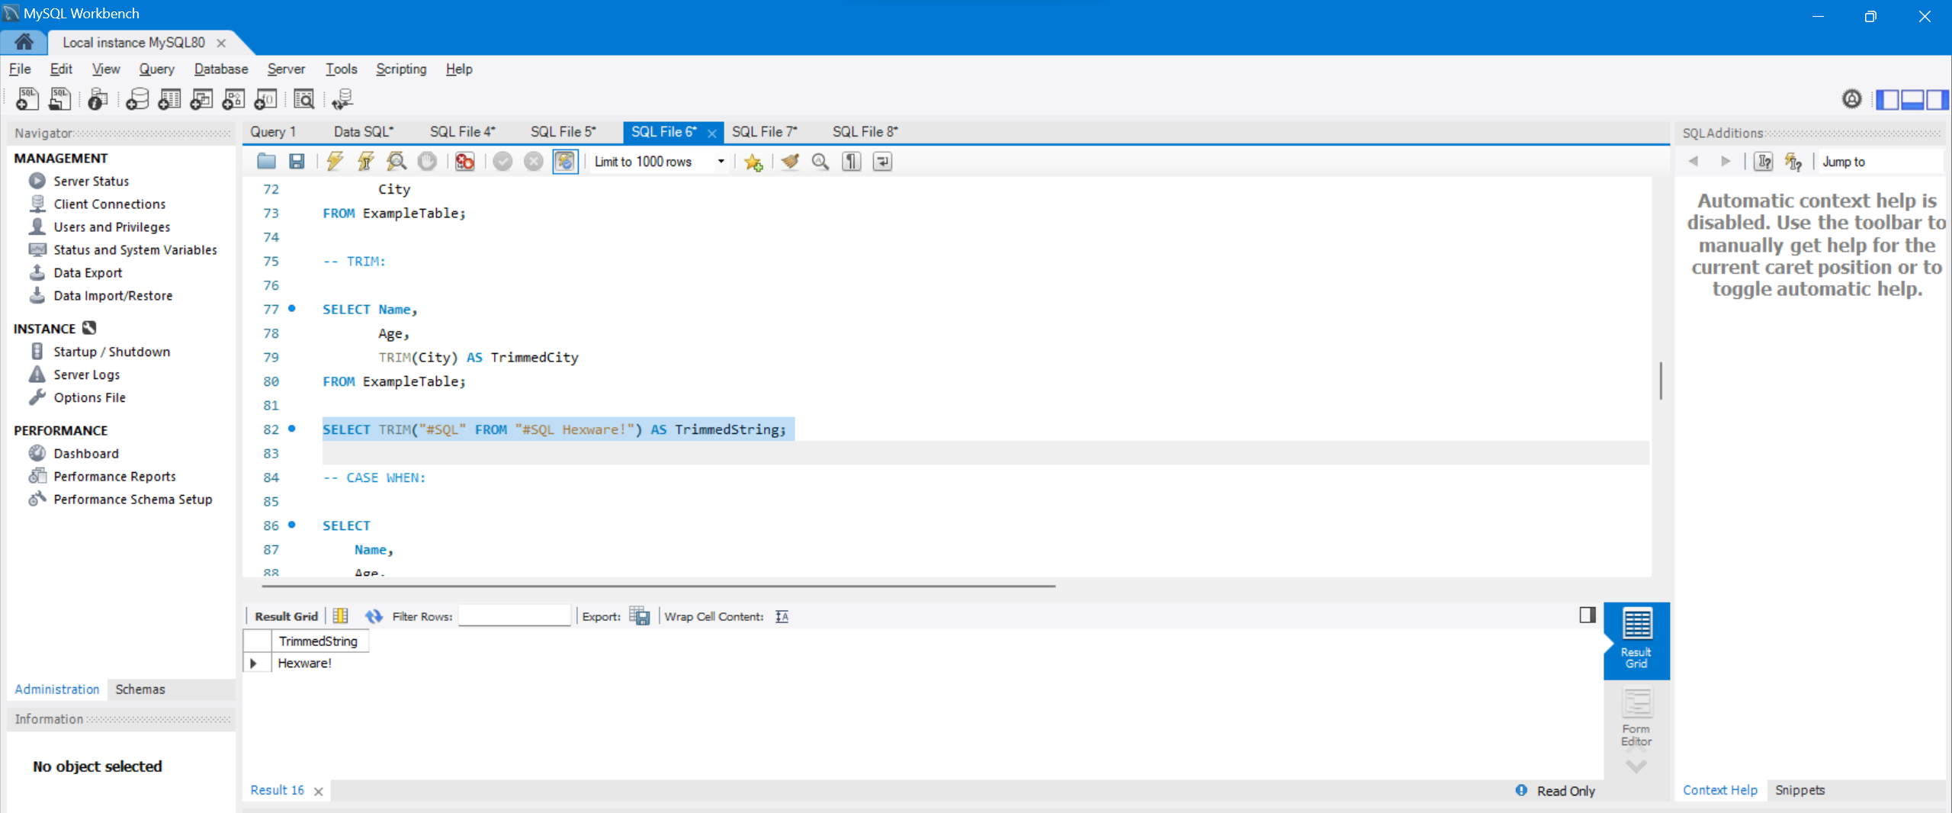

**-- CASE WHEN:**

**SELECT**

**Name,**

**Age,**

**City,**

**CASE**

**WHEN Age < 18 THEN 'Underage'**

**WHEN Age BETWEEN 18 AND 22 THEN 'Young Adult'**

**WHEN Age BETWEEN 23 AND 50 THEN 'Adult'**

**ELSE 'Senior'**

**END AS AgeGroup**

**FROM ExampleTable;**

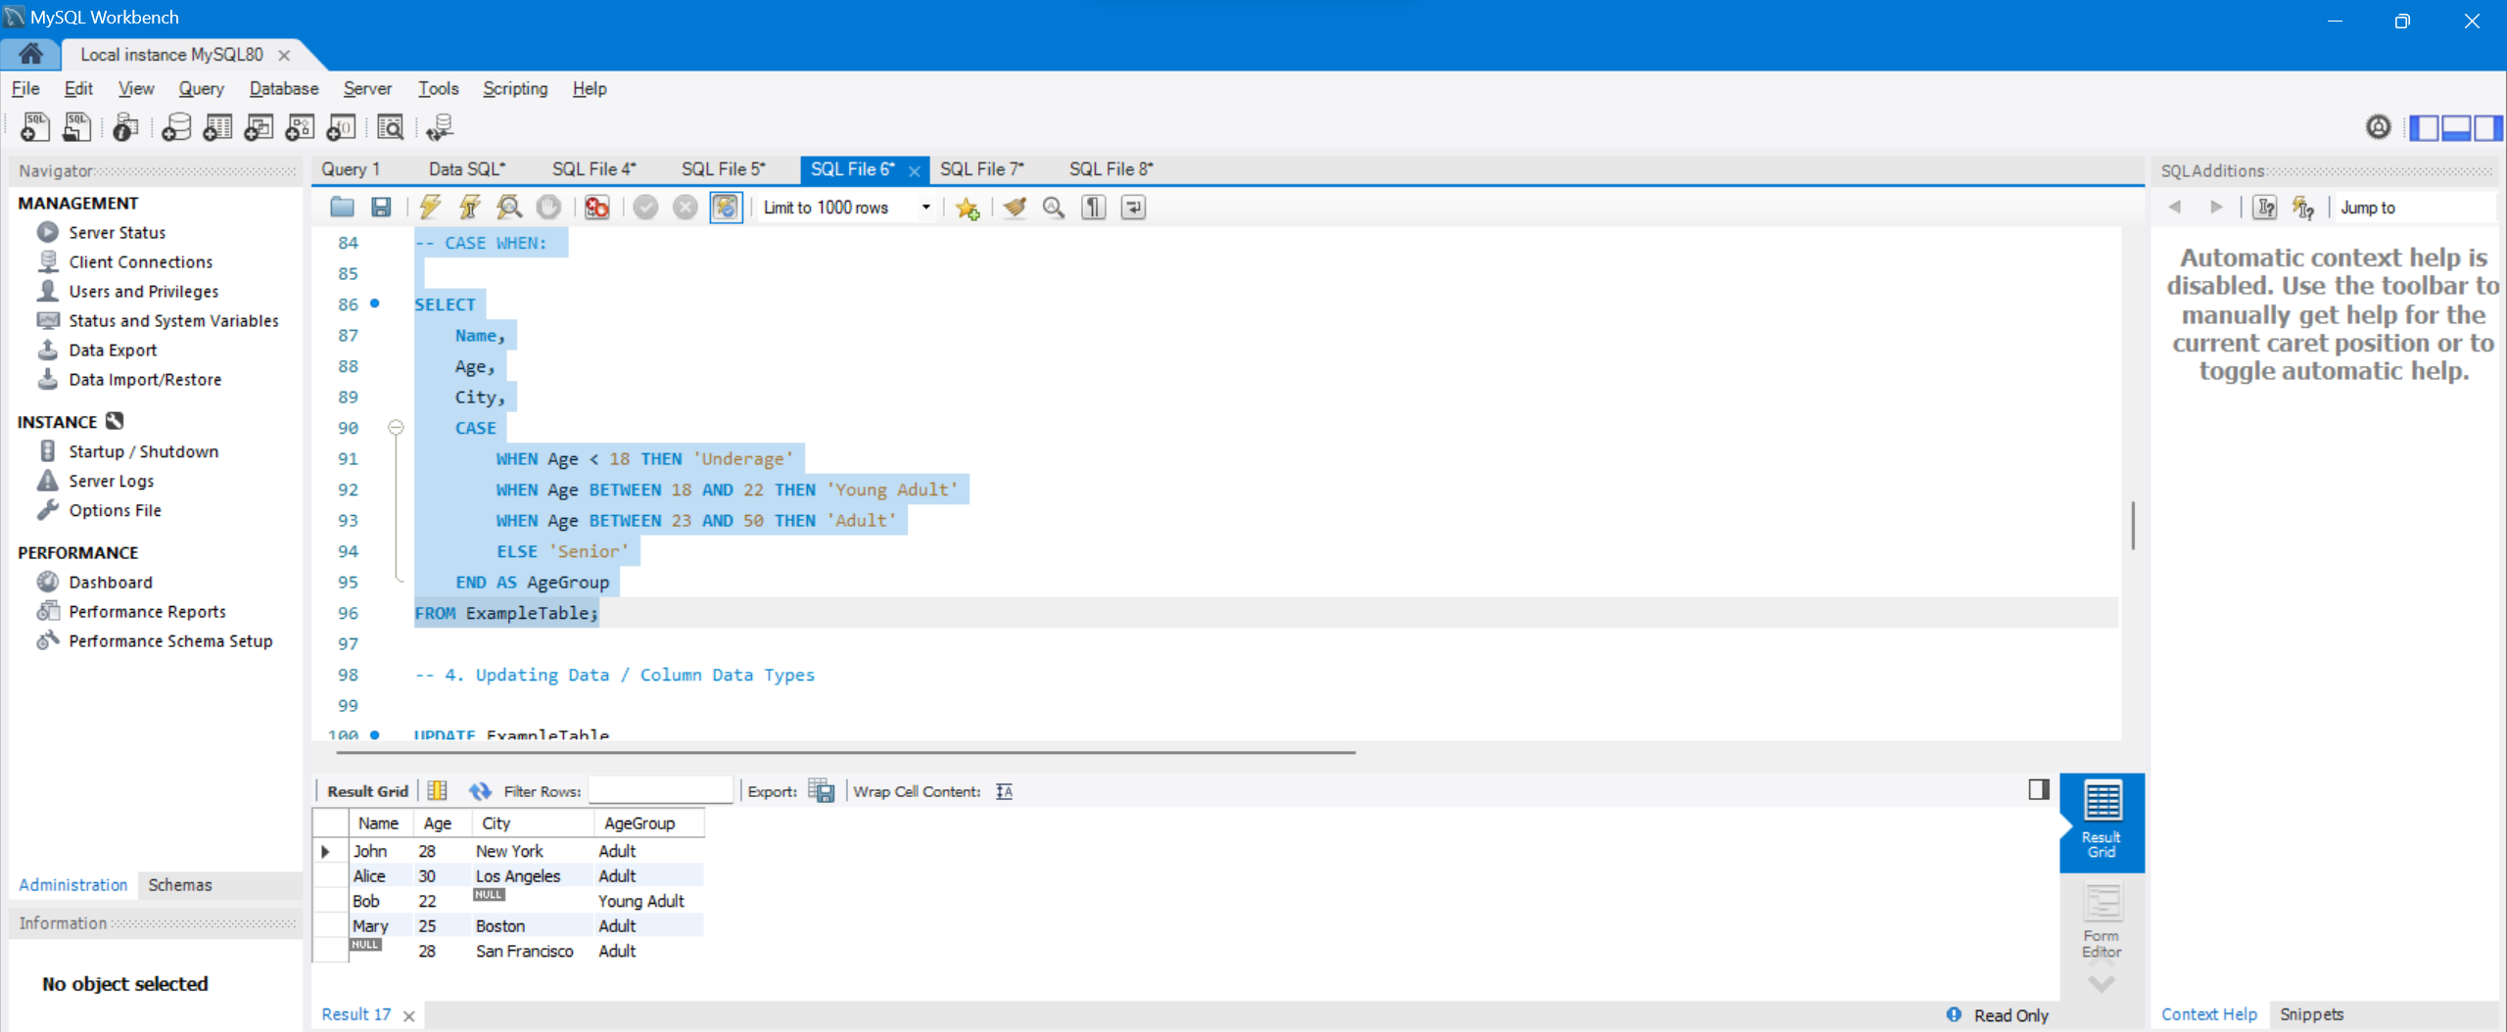

**4. Updating Data / Column Data Types**

**UPDATE ExampleTable**

**SET Age = 28**

**WHERE Name = 'John';**

**ALTER TABLE ExampleTable**

**MODIFY COLUMN Age VARCHAR(10);**

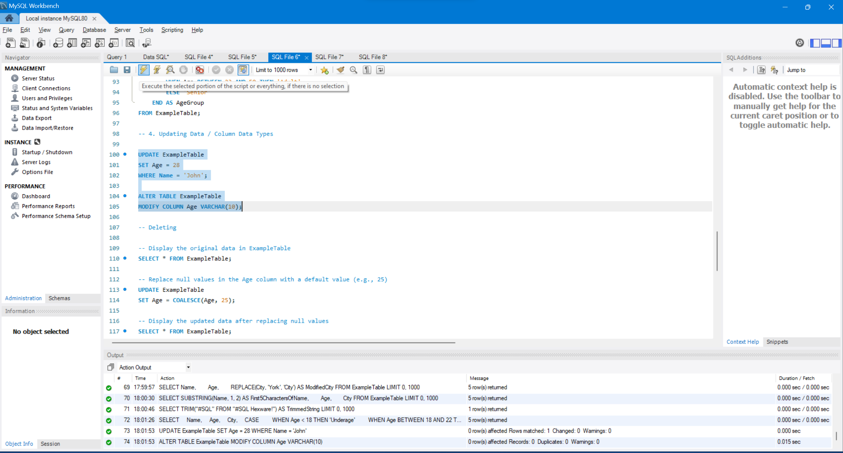

**-- Deleting**

**Replace null values in the Age column with a default value (e.g., 25)**

**UPDATE ExampleTable**

**SET Age = COALESCE(Age, 25);**

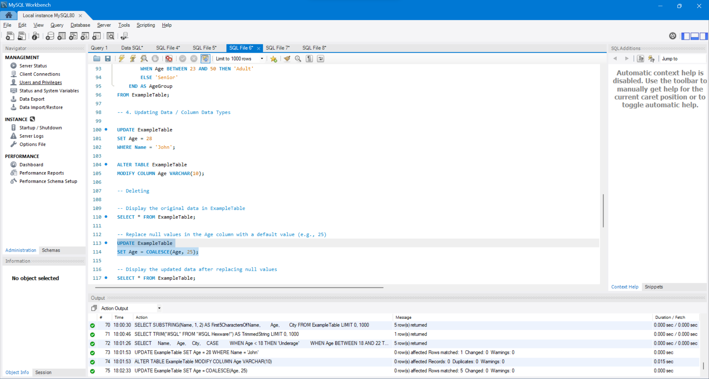

**-- Delete duplicate rows based on the Name column**

**DELETE e1**

**FROM ExampleTable e1**

**JOIN ExampleTable e2 ON e1.Name = e2.Name AND e1.ID > e2.ID;**

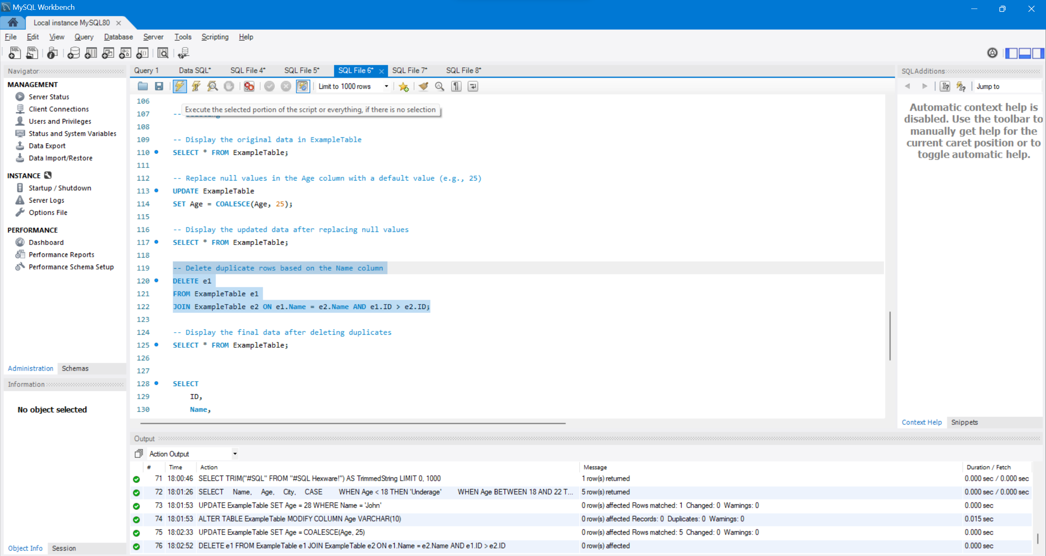

**Using Rank Functions**

**The functions are used to generate sequence numbers for each row for providing a rank based on the specified condition. The functions are provided to rank the records in the table. The following functions are provided for the rank records.**

**1) row_number()**

**2) rank ()**

**3) dense_rank ()**

**4) ntile ()**

**1) row_number()**

The function returns the sequence of numbers for each row based on the column in the result set. Each row has a number starting from 1.

Consider an example of result table. It consists of three columns as studid, course and grade. The table containing the values is as shown below:

The following query displays the sequential number on a column by using the ROW_NUMBER() function.

select studid, grade, ROW_NUMBER() OVER ( ORDER BY studid desc) as rank from result

The output for the above query is as shown below:

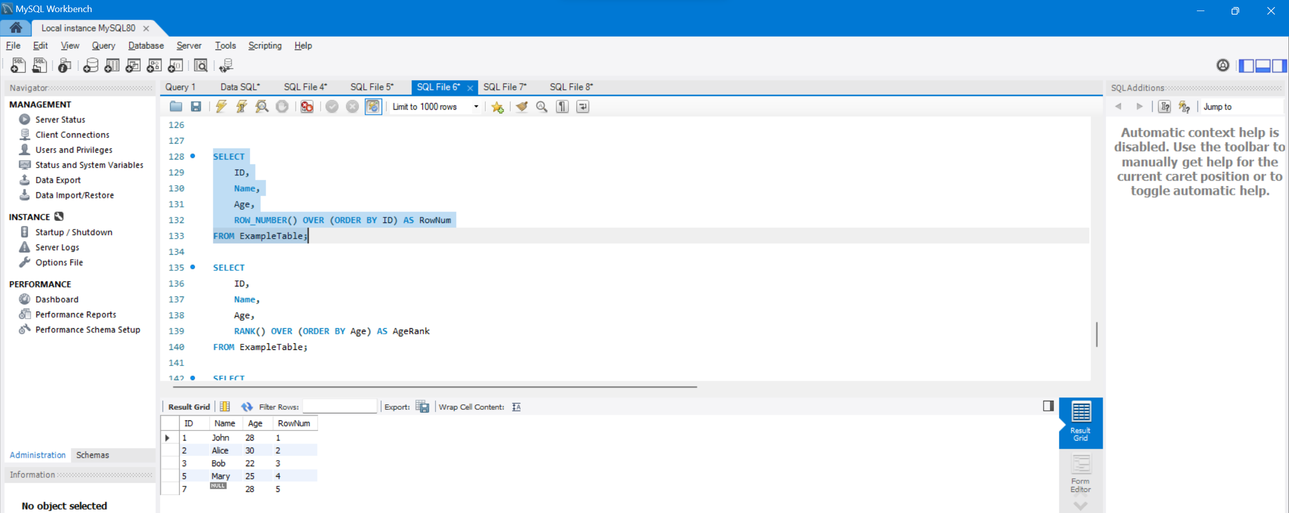

**2) rank()**

The function is used to return the rank of each row in a result set based on the specified condition. The ORDER BY clause is used with the function for the purpose of rank.

Consider an example of rate table consisting the columns as orderid, productname, and cost. The table in the SQL server is as mentioned below:

The query for use of rank() function is as shown below:

select orderid, cost, RANK() over ( order by orderid) as rank from rate

The output for the query is as shown below:

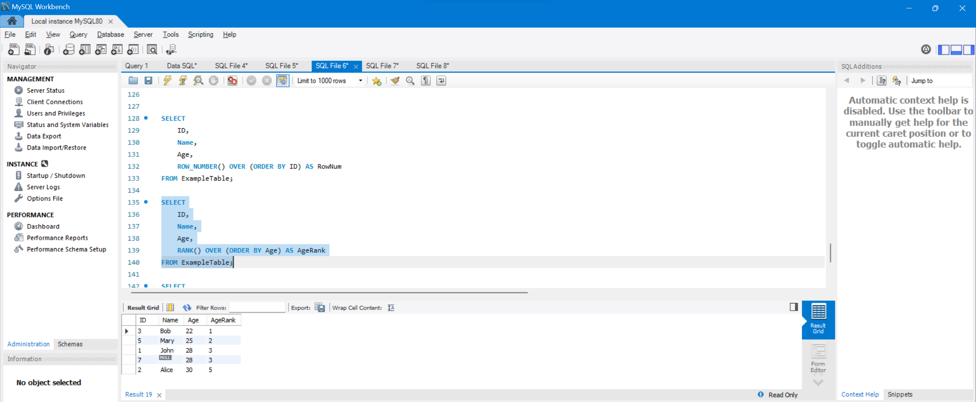

**3) dense_rank ()**

The function is used where consecutive ranking values are to be provided on the specified criteria. It performs similar to the rank function but provides consecutive ranking values as output.

Consider the rate table with columns as orderid, productname and cost.

Apply the following query with the dense_rank() function. The query is as mentioned below:

select orderid, productname, dense_rank() over (ORDER BY orderid desc) as rank from rate

The output for the query is as shown below:

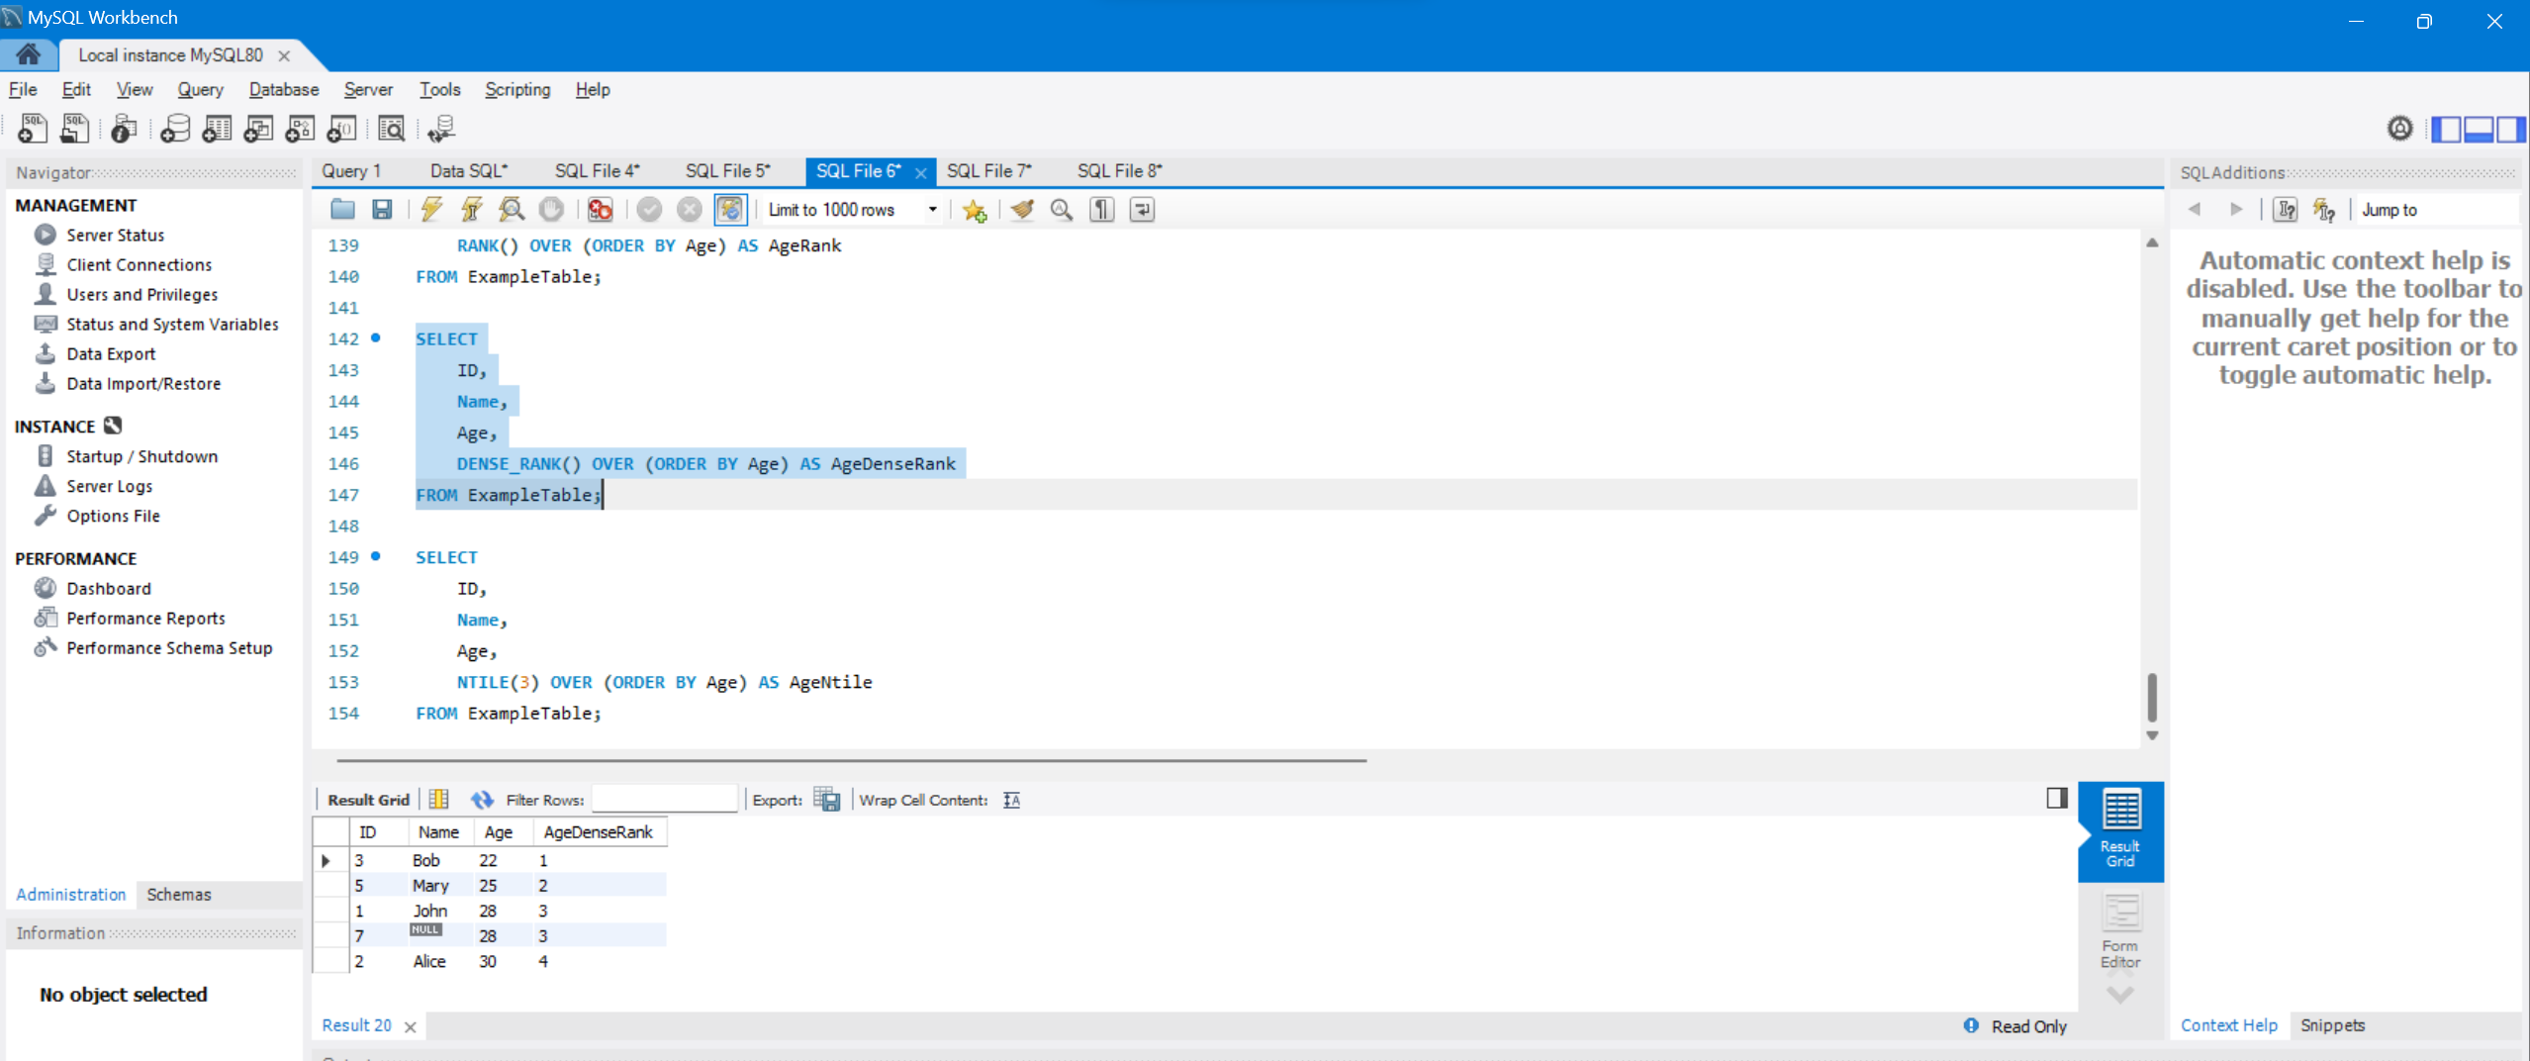

**4) ntile()**

It is used to divide the result set into number of groups. The function accepts the positive integer to distribute the rows into the number of groups. The groups has the value as 1.

Consider the examdata table with four columns as subid, subname, examdate and location as shown below:

The query using the ntile function is as shown below:

select subid, subname, examdate, NTILE(2) over ( order by examdate ) as rank from examdata where DATEPART ( YY, examdate ) > = 2011

The output for the query is as shown below:

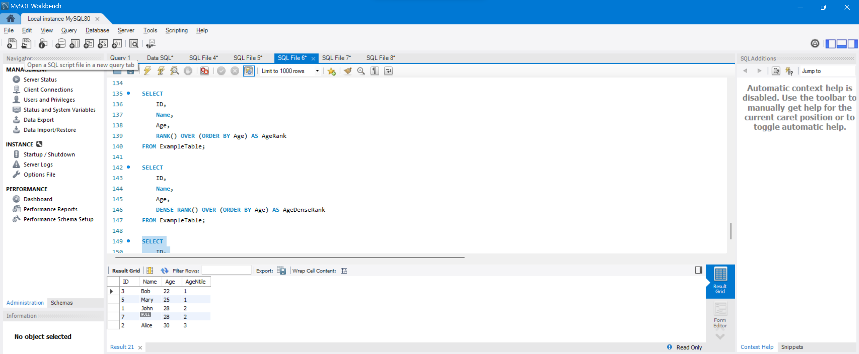

What is a Stored Procedure?

A stored procedure is a prepared SQL code that you can save, so the code can be reused over and over again.

So if you have an SQL query that you write over and over again, save it as a stored procedure, and then just call it to execute it.

You can also pass parameters to a stored procedure, so that the stored procedure can act based on the parameter value(s) that is passed.

## Stored Procedure With One Parameter

DELIMITER //

-- Create a basic stored procedure for ExampleTable in MySQL format

CREATE PROCEDURE SelectRecordsByAge(IN pAge INT)

BEGIN

SELECT *

FROM ExampleTable

WHERE Age = pAge;

END //

DELIMITER ;

CALL SelectRecordsByAge(25);

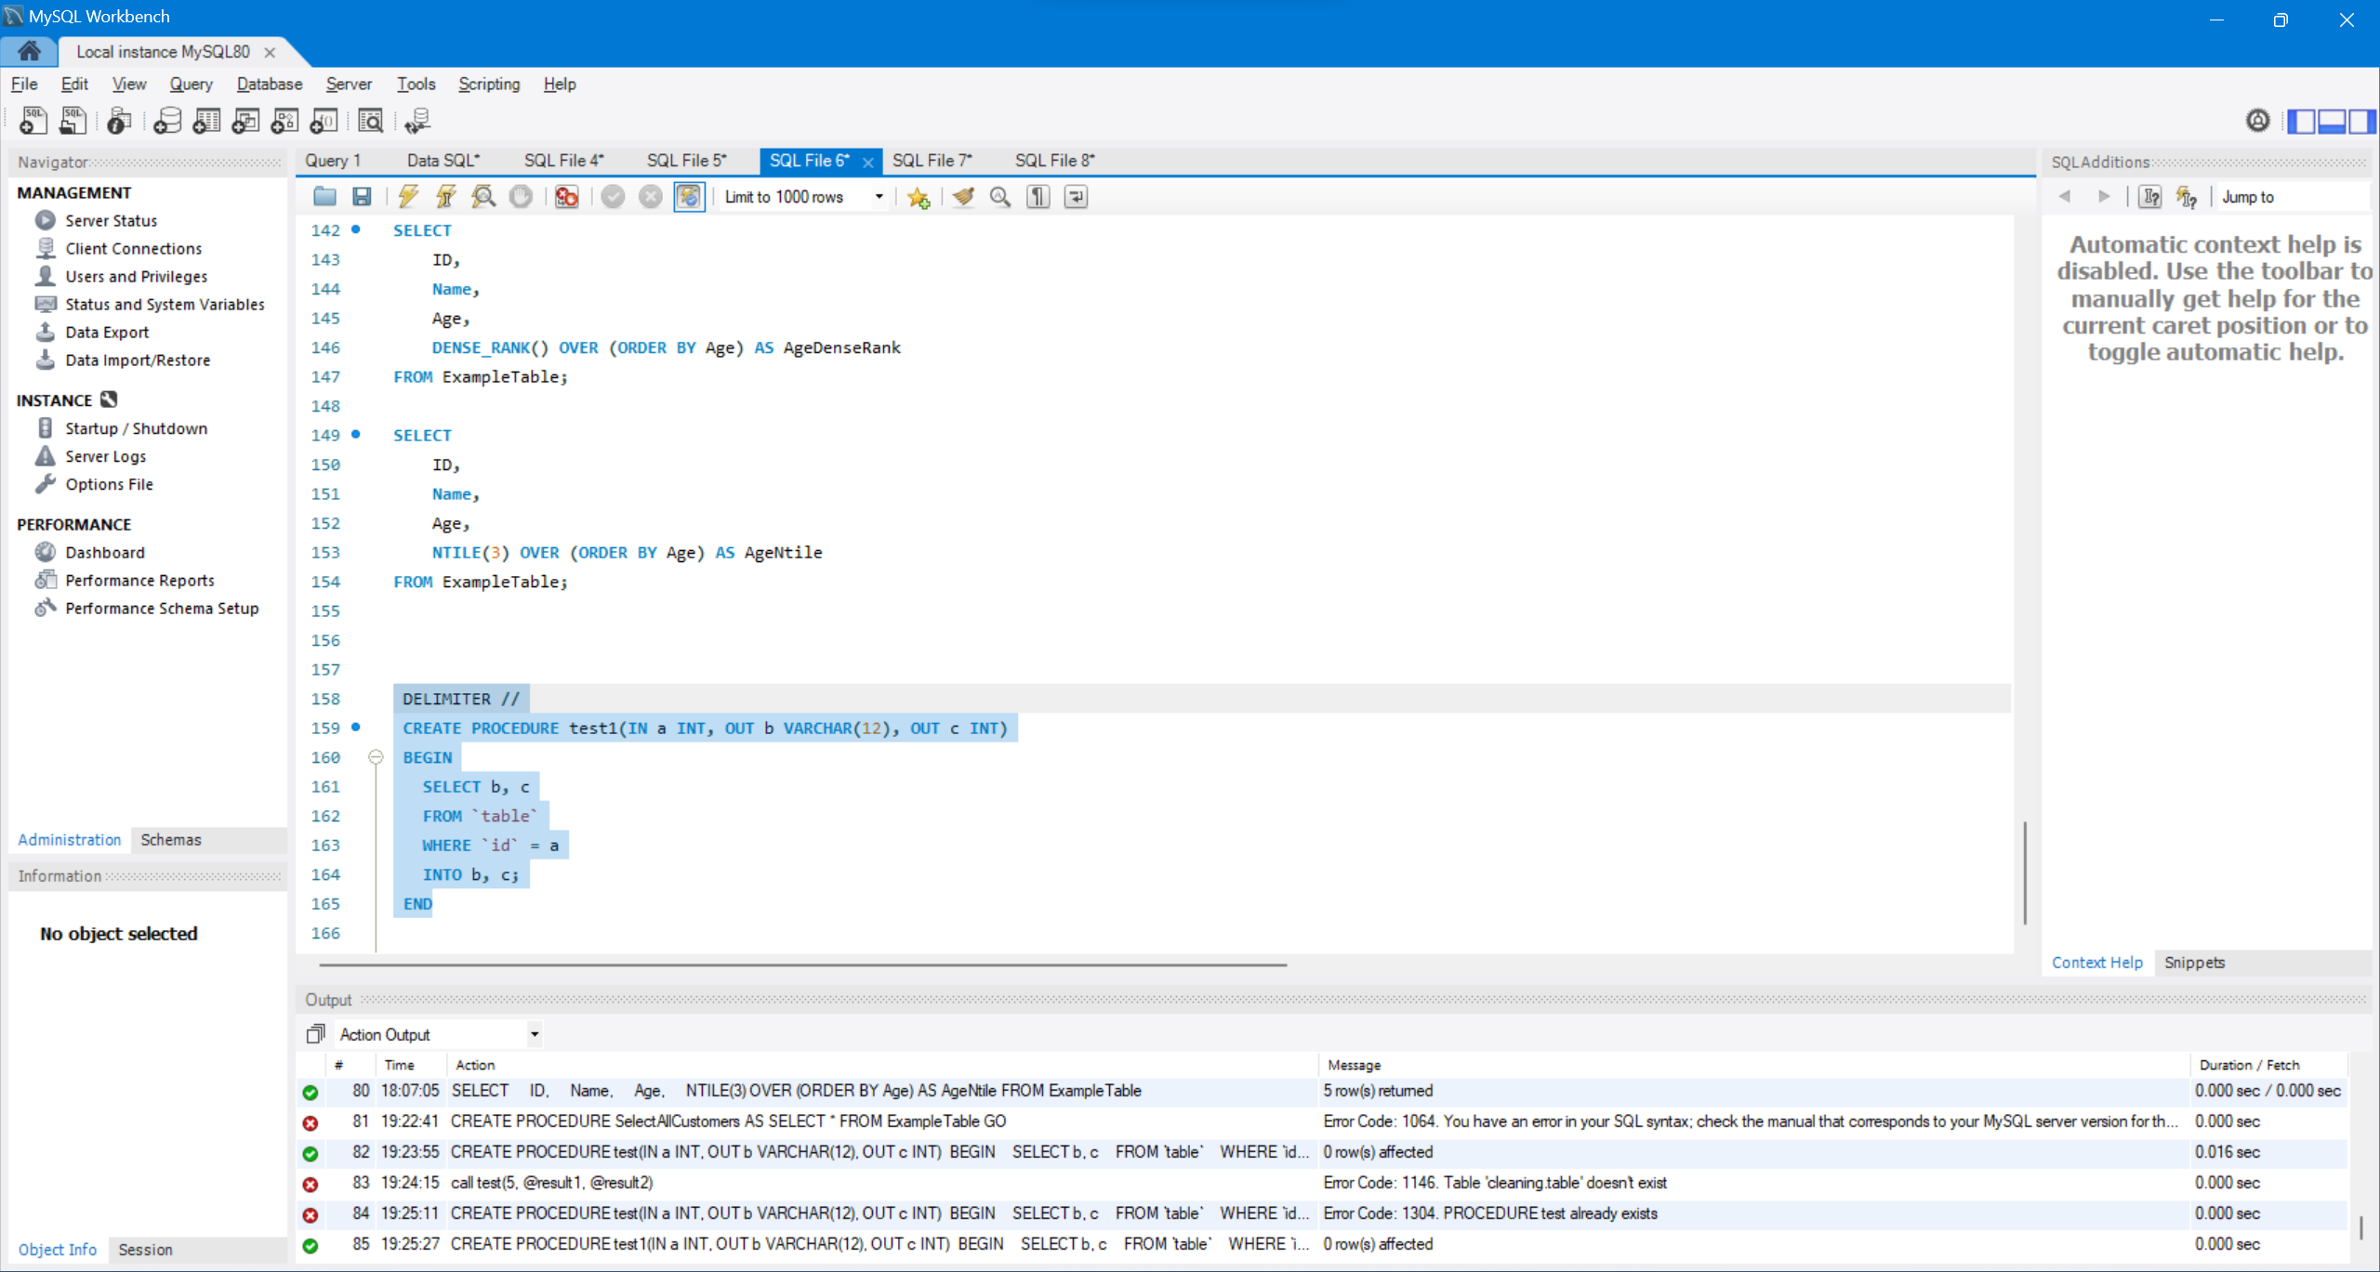

## Stored Procedure With Multiple Parameters

DELIMITER //

-- Create a stored procedure with multiple parameters for ExampleTable in MySQL format

CREATE PROCEDURE SelectRecordsByAgeAndCity(IN pAge INT, IN pCity VARCHAR(50))

BEGIN

SELECT *

FROM ExampleTable

WHERE Age = pAge AND City = pCity;

END //

-- Reset the delimiter to ;

DELIMITER ;

-- Execute the stored procedure with the parameters 25 and 'London'

CALL SelectRecordsByAgeAndCity(25, 'London');

